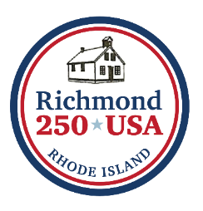
CONTEST OPEN TO ALL CHARIHO STUDENTS:
ADD YOUR CREATIVE SPIN
TO CELEBRATE AMERICA’S 250th!
The Richmond250 Commission is sponsoring a contest for all Chariho students. The elementary, middle, and high school will each be given a different theme relating to 250th anniversary of the United States of America. Contestants can respond to the theme using the medium of their choice, i.e. essay, music, poetry, painting, sculpture, drama, etc. Submissions will be evaluated by members of the Commission, and one student from each school will receive a prize of $100.
THEMES
Richmond Elementary School: A Historical Person from Revolutionary Times

Chariho Middle School: Life Then and Now- 1776 vs. 2026

Chariho High School: My Vision of America 50 Years from Now: 2076

Entries may be sent electronically to richmond250th@gmail.com or mailed to Richmond250 Commission, 5 Richmond Townhouse Rd, Wyoming, RI 02898 ATTN: Samantha Wilcox

DEADLINE: MAY 1, 2026



